**VR Simulation for General Pandemic Measures**

***Tilburg University***

**CSAI**

Members/SNR:

Djourdan Gomes-Johnson (2033032), Florijn van Zuilen (2015917), Paul Dewez (2047933), Pietro Garroni (2038045), Ndivhuwo Nyase (2047606)

Word Count: 4297

# 

# Table of Contents

**Introduction** **3**

**Planning** **3**

Project Structure and Planning: 3

Roles: 3

Sequential Development Life Cycle: 4

Sprints: 4

SMART: 5

**Background and User Research** **5**

User Research: 6

Input devices: (How users communicate with the application) 9

Output devices: (How we inform the users of our feedback) 9

**Design and Development** **9**

Client Requirements: 11

Prototyping: 12

Our semi-conducted interview: 13

Design and Build: 14

Avoiding Cybersickness: 15

Signifiers and Affordances: 15

**Evaluation** **17**

Game Instructions: 17

Limitations/contraints: 18

Improvements: 18

**References** **20**

**Appendix** **21**

A: List of Survey Questions Asked 21

B: Expert Evaluation 22

# 

# Introduction

The year 2020 is quite memorable. Foremost due to the introduction of Covid-19 and the vast affect the virus had on governments, organisations, and individuals. While governments may implement guidelines for reducing the spread of the pandemic, our application serves as a tool to inform the individuals of these social distancing guidelines. Distinctly designed for Android smartphone users, we created a virtual world that includes these four specific scenes: The Reception Room, Presentation Hall, Car Showroom, and Bar. The scenes, surrounded by a realistic environment, allow our game character to adhere to certain social-distancing regulations in realistic situations.

Our application allows users to immerse themselves in a realistic environment, promoting the possibility for engaging learning experience. VR gives an experience so memorable, that if implemented properly, will drastically increase the understanding of the guidelines, allowing people the opportunity to practice social distance measures using our application. The goal for this application is to provide a tool for people to use to inform and educate themselves with regards to social distancing measures to further increase compliance with social distancing rules and regulations.

The VR aspect of this application is very crucial as it provides us with the opportunity to create an immersive experience to make the user more aware of their consequences when they are in public. In addition to this, an advantage of using VR is that we can create an interactive environment where users can learn how to social distance correctly without putting their health and the health of others around them at risk.

# Planning

## Project Structure and Planning:

A project of this nature was always going to be challenging, moreso with the Coronavirus restrictions and the fact that our group members are scattered all across the globe. Therefore, to set up effective communication our group has decided to communicate daily, updating our members using WhatsApp Messenger. We also share resources and documents on a shared google drive that can be accessed and modified by everyone on the group. These two methods of effective communication are very helpful especially during the coronavirus period. With frequent phone calls and commitment to the project, our group will continue seeking effective communication.

## Roles:

Initially, our group's project roles were undefined. All the tasks were shared amongst each other. We strategically did this to get a better understanding of the project roles and responsibilities and our group members strengths and weaknesses. However, we did plan that for when the project becomes more specialized and technical, we would distribute tasks and responsibilities accordingly to our group members skills, abilities and experiences.

This became apparent the more we started using Unity and needed to implement user research and analysis. The tasks and responsibilities were divided amongst group members such as user research tasks, adhering to deadlines, UI and UX designers and developers.

Here you can find our tasks briefly explained:

* Djourdan Gomes-Johnson: report writer, overhead report structurer and organizer.
* Paul Dewez: locating and downloading assets from the store, optimizing the game appearance and coding the UI and game attributes.
* Pietro Garroni: building the assets, locating and downloading assets from the store, optimizing the game appearance and coding.
* Ndivhuwo Nyase: report writer, implementing and conducting the User research and Expert Evaluation.
* Florijn van Zuilen, implementing and conducting user research, evaluates responses from users.

## Sequential Development Life Cycle:

Our group followed the Agile development life cycle. This development life cycle allowed our group to put focus on collaboration, communication and modular tasks that are tackled in short and intense bursts. Our Google Drive and Whatsapp group chat allowed us to frequently communicate with each other which helped in using this life cycle. Our group attempted to divide tasks in small manageable and modular tasks to deliver our working application and project report before important deadlines. This development cycle was advantageous to us as a project of this nature seemed too large to tackle using another development life cycle and we wanted to reduce the risk of having no application by the deadline. The agile sprints could be categorized as the following:

### Sprints:

1. Project planning and Overview - This sprint was focused project planning and understanding our goals of the project, this sprint coincided with the project planning and project overview assignments
2. User Research - This sprint focused on understanding the mental models of the user in the context of our project.
3. Working on the application - This sprint was focused on understanding VR, Unity and creating a low level prototype of our game
4. Expert Evaluation - This was an intense sprint as we wanted to have a mid level working prototype of our application so that we could have experts to evaluate our project.
5. Working Demo - This was also an intense sprint as we decided to use the expert evaluation to further develop and improve our application.
6. Project Report - The last sprint is the project report. This was also an intense sprint and has to do with writing the project and individual self evaluation

## SMART:

Finally, It was important to have an objective-driven approach when planning and developing our application as an application of this magnitude has the potential to have problems. Therefore we implemented the SMART objectives to plan and manage tasks that have to do with developing our application and adhering to deadlines.

# Background and User Research

Coronavirus disease (COVID-19) is an infectious disease caused by a newly discovered coronavirus. As Coronavirus is a very sensitive subject, it became a requirement for our group to inform ourselves about the Coronavirus, social distancing measures and how people can get infected with the Coronavirus.

This background research was crucial as we wanted to cater to as many users as possible while controlling for user factors such as demographic background and cultural background. Furthermore, it was of the utmost importance that our game was relevant and consistent with the Coronavirus social distancing measures and regulations implemented by people and government alike.

As the second wave became more apparent not only in the Netherlands, but in Europe the need for citizens to comply with the Coronavirus measures became increasingly important. Our group's task was to increase compliance of social distancing measures amongst users. We decided to use the three main measures against the Coronavirus implemented by The World Health Organization and the Netherlands government and use these measures in our game .

1. Wash your hands frequently
2. Maintain at least a 1-metre distance between yourself and others to reduce your risk of infection
3. Wearing a mask in public spaces

This game will be a helpful tool to train and encourage users to respect the safety measures and make them realize how a small action like wearing a mask could prevent a person from getting the Coronavirus.

To increase compliance with the Coronavirus measures, our game had to have tasks for the user to complete. These tasks were in the form of virtually moving in the virtual environment whilst attempting to adhere to the Coronavirus regulations. Measures such as staying 1.5 meters away from other people, wearing a mask in public locations and hand sanitizing hands frequently. To create tasks for the user, our group used the GOMS processor models that describes a users cognitive structure on 4 components, Goals, Operators, Methods and Selection Rules.

An example of the GOMS process being used in our game is to follow the Coronavirus regulations.

Goal: The goal of this task is to wear a mask to prevent the disease from spreading.

Operator: The operator is where the Bluetooth Controller the user would be using for movement and interacting with objects.

Methods: There are two methods to wearing a mask, which is to simply walk over the mask in the game or to press a button to pick up the mask in the game.

Selection Rules: The selection rule of picking up the mask was to reinforce or learn how to social distance correctly while being engaged and feeling like our game is an interactive experience. Therefore we choose the method of pressing a button to pick up the mask as it is more interactive and engaging as compared to walking over the mask.

## User Research:

Before starting with our application, it was crucial to develop a mental model for our users. In addition to this, we wanted to know more about our users to ensure that we could make the application feel comfortable to them. Thus we needed to get to know our users, who they are, what they wanted and needed. We also wanted to get to know their experience with video games in general and especially VR games. But also to test their knowledge about COVID-19 and how it spreads prior to playing our game. For the best outcome of our user research we wanted to interview our users. However, due to COVID-19 this was not possible. That is why we chose to make a survey with 23 questions in total. We sent this survey out to the first year students of Cognitive Science & Artificial Intelligence as this was our main user.

From this survey we could see that the technological skills of our users was higher than average. No one rated themselves lower than a 6 on a scale of 1 to 10, with an average of 8 and the highest rating being a 9. Also, the majority of users play video games regularly. The number of users that play video games was relatively high. 55,6% of the users said they played video games with 11,1% daily users, only 33,3% said they didn’t play videogames at all. Most of our users, 66,6%, had prior experience with playing VR games. With 11,1% having played VR games more than once.

***Figure*** *: How would you rate your technological skills?*

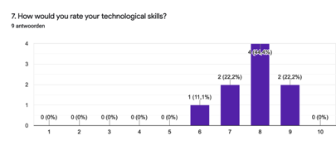

***Figure****: Do you play video games?*

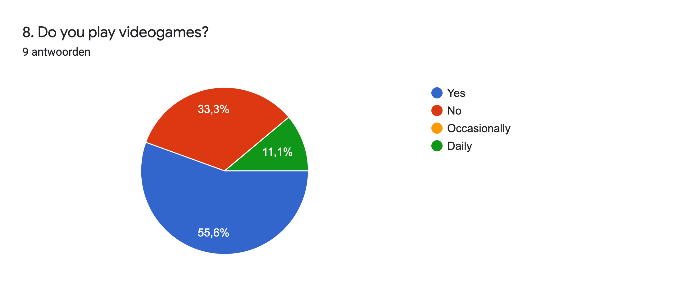

***Figure****: Have you ever played a VR game?*

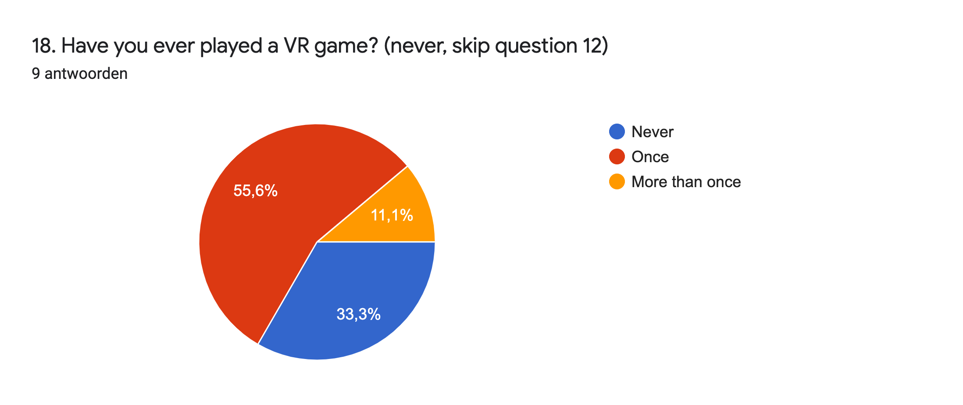

These results were expected, as students who applied to CSAI on average have more interest in technology than students who chose a different field of study. Furthermore, none of our users had ever experienced cybersickness while playing VR games. We used this information while building our application. Taking into account that there were users who don’t play videogames and have never experienced VR of any kind, we needed to make sure that the game was not too difficult for our users, ensuring they could play with ease and smoothly.

According to the survey, the users had prior knowledge about how COVID-19 spreads and what the regulations are. With most users stating they were fully aware of how COVID-19 spreads(44,4%). With regards to practicing social distancing, everyone stated they do this, with 77,8% only doing it in public places. Almost all of our users always wear a face mask (88,9%) and some wear it sometimes. The majority of users also said that they think social distancing is one of the key aspects to slow the spread of COVID-19. This was very helpful with our game because we knew that most of the players would steer away from bots without the explicit need to tell them.

***Figure****: How aware are you of how COVID-19 spreads?*

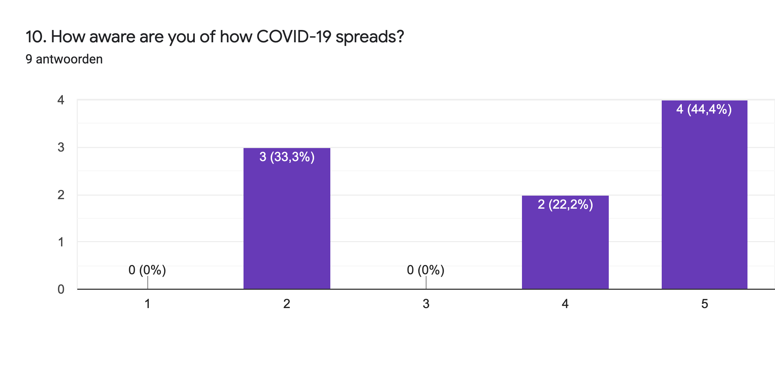

***Figure****: Do you practice social distancing yourself?*

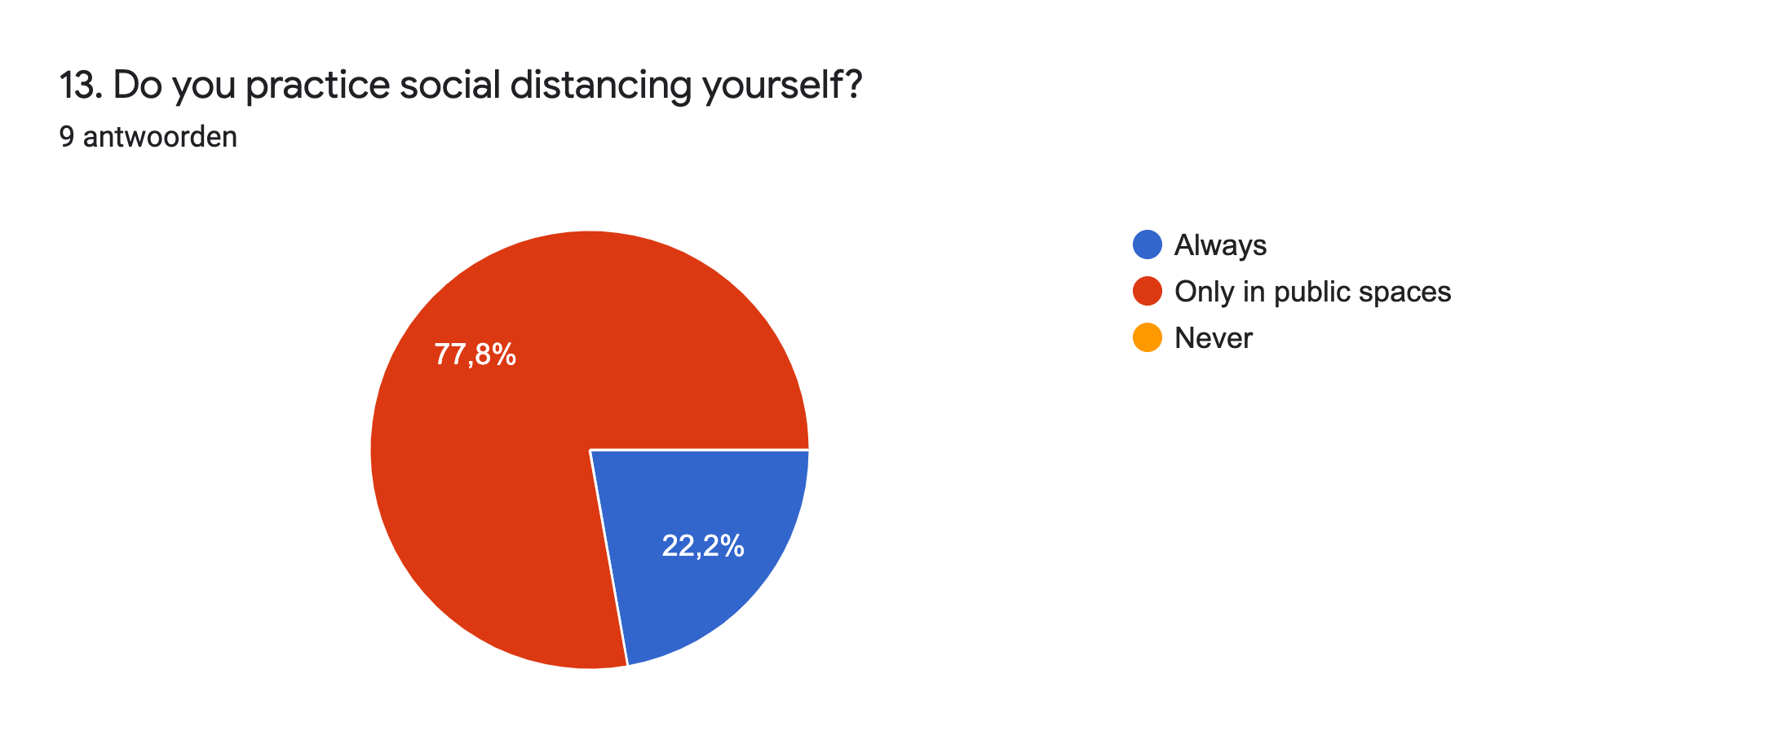

***Figure:*** *Which of the below measures do you think best decreases the chances of infection?*

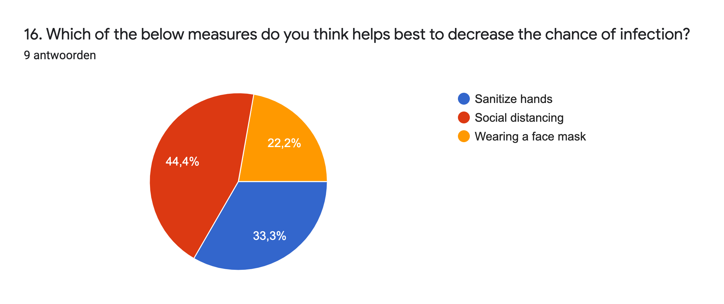

We found out that it was very important for our users to be fully immersed in the VR world. The users could rate the importance on a scale of 1 to 10, with 1 being not important and 10 being crucial. The average was an 8 with the lowest score of 6 and the highest being a 10. The least favorite aspects of VR according to our users were different but most of them had problems with VR itself. Whether it was that VR is rather expensive or that the goggle itself was the problem due to the fact that it slides off your face or being considered heavy. To satisfy this we tried to maximize the feeling of being immersed by having them interact with objects in our environment. We could not make their least favorite aspects of VR have no impact on their experience while playing our game as this was beyond our control.

## Input devices: *(How users communicate with the application)*

* Bluetooth Controller with an analog
* Smartphone in a VR headset that tracks motion, direction,eye and head movements

## Output devices: *(How we inform the users of our feedback)*

* Action or change in VR environment
* Audio cues
* Visual cues in the VR environment
* Change in location and position as user moves

# Design and Development

A natural goal during the design and development was to narrow both the Gulf of Evaluation and the Gulf of Execution. Our immersive environment provided an effortless route for user success in our game objective. This is primarily achieved through easy understanding of our game objects. The masks, arrows, infected bots, and hand-sanitizer stands are simply designed and require minimum comprehension for their respective affordances.

The figure below, a screenshot from the game, illustrates an example of constant feedback and physical interaction presence which reduces the gulf of evaluation. The arrow (signifer) is designed to assist the user, directly allowing the users to perceive the artifact and react to it appropriately. The same applies to the warning sign, the red color acting as an aesthetic match between the two, and furthering the importance of these symbols for the achieving of the user goals. The infected bots allow the user to emerge themselves in the environment, understanding the importance of distancing through interactions (or avoidance) of the infected bots. These visible, simply designed objects give immediate feedback to the user and allow our virtual world to include a sense of social presence.

***Figure:*** *constant feedback and social presence*

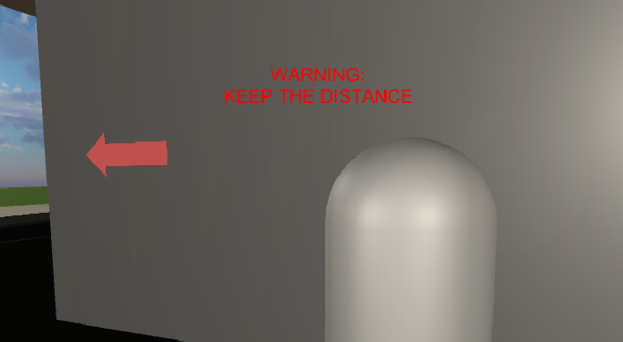

***Figure:*** *infection bot*

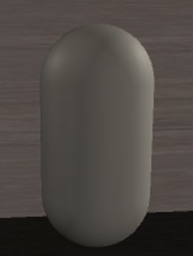

The figure below displays the mask that rotates on its axis. The importance of the mask rotating on its axis is that the users can identify which objects they can interact with and ( Increasing visibility of interacts ) are able to have a smoother interaction with the object. The mask demonstrates the importance of helping the user execute their goals, essentially reducing the Gulf of Execution. Aside from the mask, the Gulf of Execution was narrowed by giving every instruction needed when the game is started in the in-game menu, so that the users understands which key to use and how to obtain a certain goal.

***Figure:*** *rotating mask*

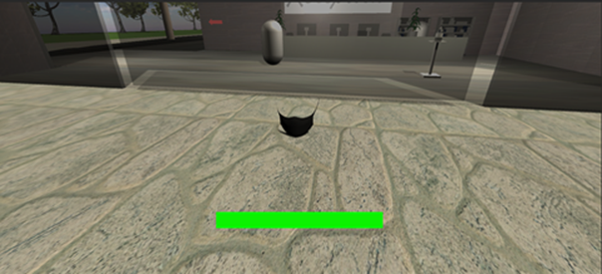

***Figure:*** *mask is required!*

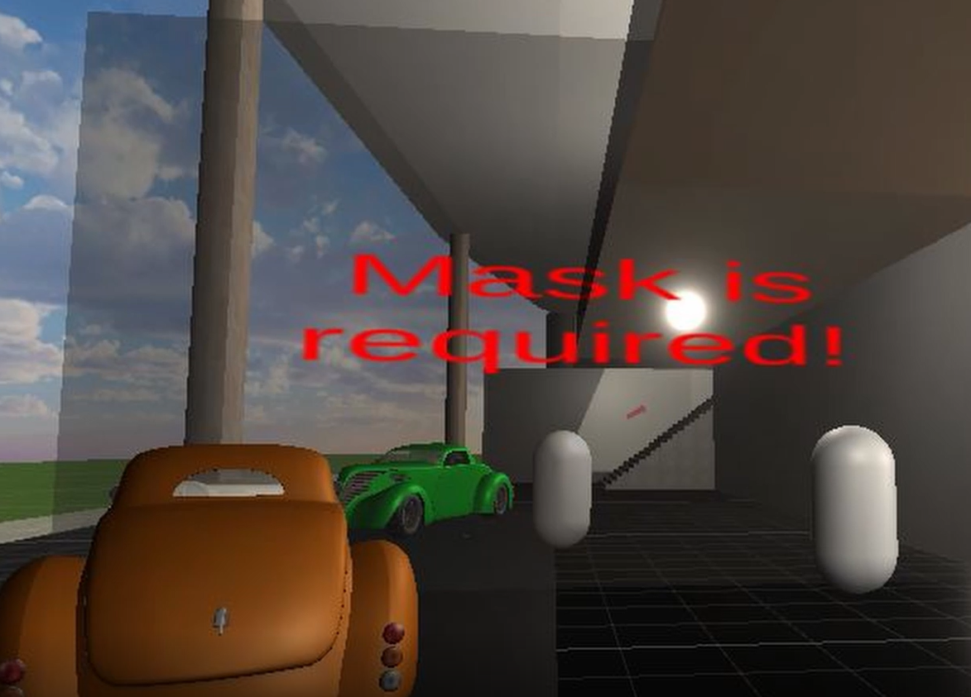

Furthermore, another way we decided on reducing the gulf of evaluation is by making our environment a see through building/mall. By implementing the see through design, it allowed for a lot of sunlight to come into all the different locations in the mall thus making every location of the game visible, discoverable and accessible therefore reducing the gulf of execution. The example of this is in the figure below

***Figure:*** *open world environment*

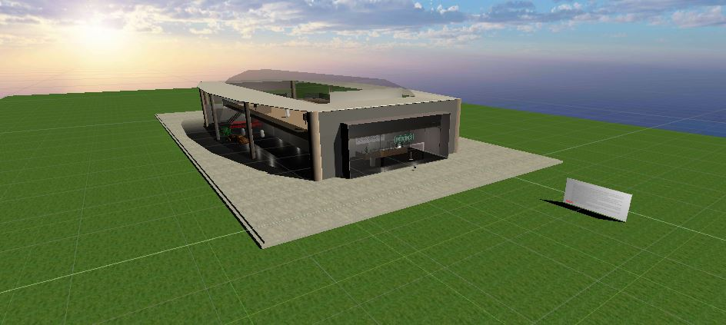

## Client Requirements:

Our Agile design not only stressed collaboration within our group, but also to our testers and clients. This open world design promotes a more enjoyable experience, facilitating the incorporation of feedback and rewards. This fundamentally shaped this VR experience, tailoring our design to appeal to the clients and users. This aids in their illusion of control, addressing the client requirements

Nielsen’s first usability heuristic, visibility of system status is crucial to our application. The final game state informs the users of their failing, or winning. The “YOU WON!” is an indicator, telling the user that the level is complete, visually awarding their performance. Below are the two final game state indicators.

***Figure:*** *final game state*

|  |  |
| --- | --- |
|  |  |

The figure below also highlights Nielson’s heuristic, informing the user of their performance in social distancing, providing immediate feedback. The health bar is an intuitive and familiar practice in games, an experiential cognitive action.

***Figure:*** *health bar (full, medium, low health)*

|  |
| --- |
|  |
|  |
|  |

## Prototyping:

We decided to use low-fidelity prototyping to perform user research. Our group wanted to understand the mental model of our users and investigate what is intuitive and familiar with our users.

We compared two low-level prototypes which covers the interaction between objects and designs in our game. This was done by paper and we used convenience sampling as opposed to other sampling methods as it was increasingly difficult to perform user testing while the Netherlands lockdown measures were strict.

Furthermore, this user testing was done by means of semi-structured interviews. Therefore, we had a set of questions we asked, however we allowed users to be open, explore new ideas and make suggestions.

|  |  |
| --- | --- |
| ***Figure:*** *Low-fidelity Prototype 1* | ***Figure:*** *Low-fidelity prototype 2* |

In prototype 1, the users will interact with the mask, hand sanitizer by pressing a button on the assigned controller. In contrast to prototype 2 where users interact with objects by walking over the mask and hand sanitizer.

Moreover, in prototype 1, there is a health bar to indicate the amount of health your character has. However in prototype 2, there is a COVID-19 warning sign that signifies the social distancing measures of Coronavirus. Both these methods attempt to increase the users compliance in adhering to the social distancing measures as the health bar will act as a gamified element in losing health which is equivalent to contracting the Coronavirus.

## Our semi-conducted interview:

To make the user feel engaged and our game more interactive, we decided that we would implement pressing a button to retrieve/use objects in our game such as the mask and the hand sanitizer. In addition to this, to press a button to retrieve or use in game items is also familiar and intuitive with the users as it is consistent and the standard in many games, which is a Usability Heuristic.

Furthermore, our group decided on using both the health bar and the warning signs. We decided on using the health bar as it is consistent and standard in many games thus making it intuitive to users.

In addition to this, our group decided to use a warning sign as a method to encourage users to implement social distancing measures. This follows the matching between the system and real world usability heuristic, as many of our users are familiar with the warning signs of Covid-19 and it maps the real world design to our game.

Finally, our prototype testing revealed that users seemed to prefer an open building/mall design which is better in VR design as it could reduce cybersickness as it prevents users from feeling "box in" or disorientated.

## Design and Build:

The building’s 3D file was created by us; we decided on this to create a modern looking building with a minimalistic design to adhere to the usability heuristic aesthetics and minimalist design. In addition to this, the presence of glass around the building was placed to enhance the lightning inside, to avoid the impression of being too constrained and allow the user to orientate himself in order to avoid cybersickness.

When creating the environment, as said above, we decided to go for a minimalistic design, but our initial idea was to use more assets and textures; for optimization reasons most of those aesthetic features had to be removed. They could have improved the representational fidelity of the environment, but even without them our game resulted to be still realistic enough.

Another important aspect that was taken into consideration was creating protections on the first floor (the presentation hall) to avoid fear of height.

***Figure:*** *Screenshot of the 3D model that was used.*

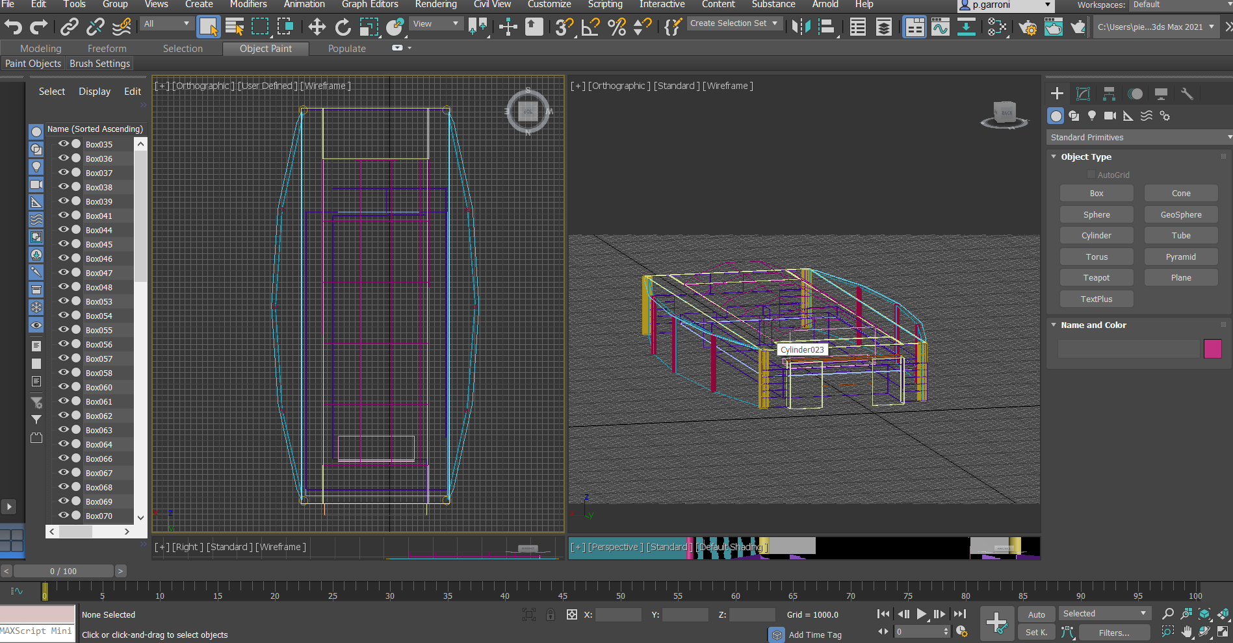

**Figure:** An example of the see through minimalist design of the environment. 

## Avoiding Cybersickness:

A very important aspect of VR is to minimize the potential of users experiencing cybersickness. As VR is still a new and emerging human computer interface that many are still getting used to, many users tend to suffer from cybersickness. Our application attempts to use good HCI principles while keeping in mind the discomfort and sickness a user can have when the application doesn't match their sensory expectations.

1. Since inside the environment the user has to move around in an FPS character, we decided to include a VR tunneling effect, which is an asset that reduces the field of view of the virtual world when the head is moved which then decreases vection; VR tunneling is a valid solution to avoid cybersickness due to sensory conflict and it is already been tested by experts (Buyuksagis, Sedat & Gursoy, Mustafa (2018)).
2. We designed our game to be completed in less than 5 minutes as long VR experiences can increase the potential of users experiencing cybersickness.
3. Our application avoided using rapid movements and position changes
4. Our application used fading in when first entering our game

## Signifiers and Affordances:

Furthermore, Signifiers were another thing we gave a lot of importance, in our game it’s possible to see them all over the map, for example the signs, the names and other information-carrying objects are always grounded to the previous knowledge of the user;

When the affordance is not clear enough by itself (as it resulted in some user testing and research), further information is briefly explained in the canvas with the instruction at the beginning of the game.

***Figure:*** *example of signifier (exit sign)*

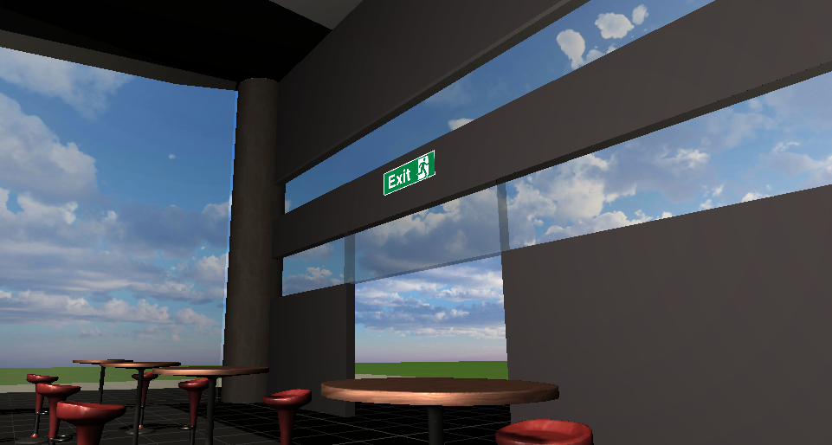

***Figure:*** *screenshot of the information visible on the canvas*

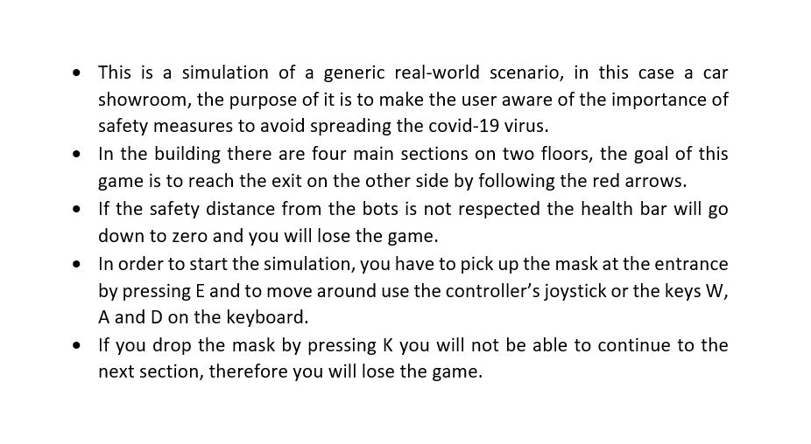

# Evaluation

A very crucial aspect of our user research and evaluation process was the expert evaluation. Our group has conducted the expert evaluation to prioritize and evaluate which heuristics and tasks are most important to our game.

The following tasks were given to the experts.

## Game Instructions:

1. Movement in and around the supermarket
2. Entering and exiting the supermarket
3. Picking up items in the game e.g mask and hand sanitizer
4. Going upstairs
5. Going downstairs
6. Keeping distance from users

The expert evaluation done by HCI group 13, showed that our game still needed work as it violated a number of the heuristics.

1. Informative Feedback
2. Help and documentation

The expert group stated that the feedback was initially unclear in the beginning as they had

The expert group criticized the lack of help and documentation with our game. As developers and designers we didn't consider this as an issue initially as we believed the control mechanisms were intuitive and easy to use. However, after evaluating the feedback, we decided to go back into the drawing board, iterate and improve on our game. Resulting in our group creating a small in game menu that the game character spawns in front of. The in game menu explains the purpose of the game, gives instructions and controller guides to interact with objects in our game e.g picking up a mask. The image below demonstrates our in game menu that describes the rules and description of the game that we added after the expert evaluation.

***Figure:*** *Image of the in game menu added after the expert evaluation*

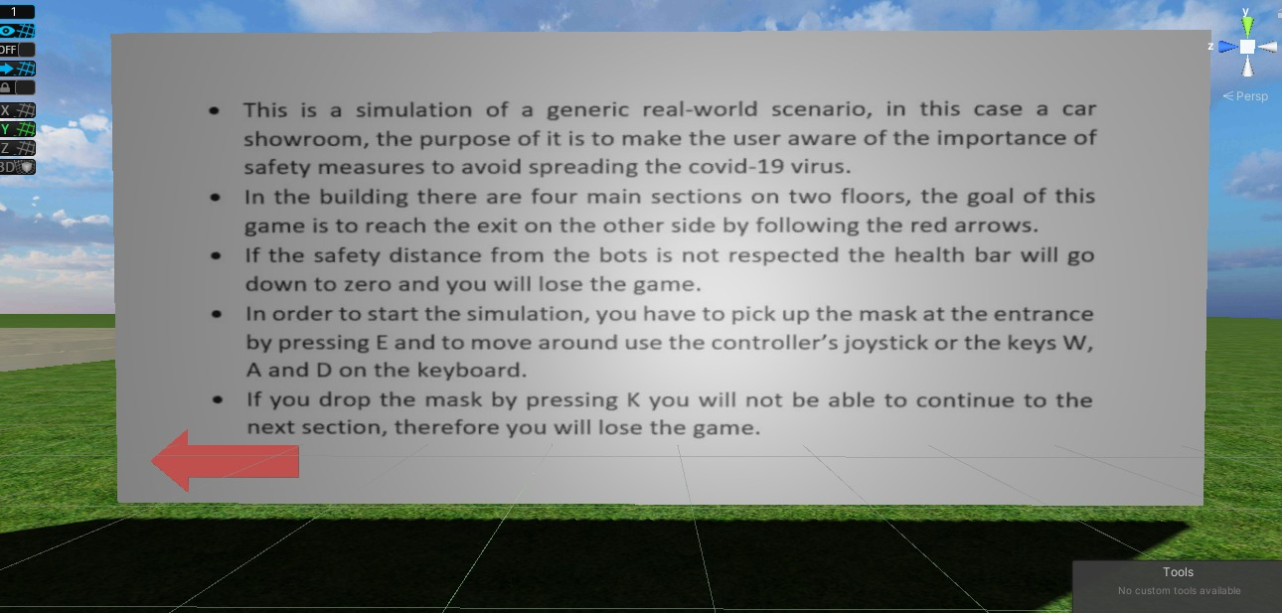

Moreover, the expert group did compliment us on our use of matching between the real world and the game. This is because Covid-19 is relevant today and items in our game such as mask and hand sanitizer remind the users of social distancing measures.

## Limitations/contraints:

In our application, there are some features that were not implemented properly such as the hand sanitizer dispenser. In addition to this there were other issues caused by the limited trials on android phones and the limited number of devices we could try it on.

The application at the current final stage does not allow the user to stop the game or make any choice regarding the settings of the game, which we planned on implementing.

Moreover, our group wanted to implement a restart button, which would allow users to restart the game and try again. This functionality was going to satisfy the usability heuristics of error prevention and error management. However, due to time and skill constraints we decided against it.

In the next section below, we will discuss the potential improvements that we would have liked to implement in our game but couldn't due to time and skill constraints, for a more complete and mature project.

## Improvements:

Our application does have room for improvement. If we were to implement another development cycle to further iterate, design, develop and implement for our application, we would implement the following:

1. Add Sound effects when using/picking up items in the game. For example when picking up a mask our game would provide positive audio reward response as feedback.The sound effect would add another layer to the sensory feedback. The sound effect would provide varied feedback output for the user to interpret thus reducing the gulf of evaluation.
2. Add the interactive element to the hand sanitizer (with a similar mechanism to the one we used for the mask) to increase the engageness of the game.
3. Implementing a menù where all the information could be found at any time of the game. This would further satisfy the help and documentation heuristic as the menu that could be found at any time would contain controller settings,objectives of the game and the ability to restart the game.

1. In order to make the application public it would have been nice to build other environment and let the user be able to choose their own environment. This element would further increase the stickiness of the game as it would encourage a community based behaviour amongst users.
2. Adding more icons, symbols and interactions. To match the real world and the game further, we would add icons, symbols and interactions that relate to the coronavirus. For example, a warning sign on the floor to encourage users to follow the Coronavirus measures, similarly to the warning signs below.

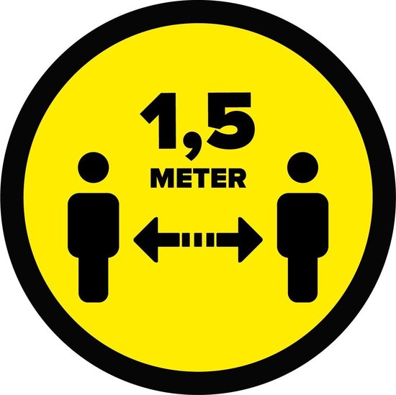

1. Have an interactive test with Coronavirus related questions at the end of the game to further increase compliance with the Coronavirus measures.
2. Find a way to optimize the efficiency application and make it possible to make it run smoothly on portable devices like smartphones.

# References

Buyuksagis, I. Sedat & Gursoy, Mustafa. (2018). *Augmented and virtual reality practices in the tunneling training*.

Unity Assets:

Dynamic Art, (2016) [Computer software]. *Low Poly Street Pack.*

Ferocious Industries, (2018) [Computer software]. *FREE Rockstar Asset Pack.*

Flamingsands, (2016) [Computer software]. *80’s Sport Car.*

Haberle, M., (2018) [Computer software]. *Hot Rod.*

Next Level 3D, (2019) [Computer software]. *HQ Acoustic System.*

RCC Desing, (2018) [Computer software]. *Hatchback and Sedan.*

SimpleModelsForMe, (2019) [Computer software]. *Barprops.*

Whitelock, R. (Rpgwhitelock), (2019) [Computer software]. *AllSky Free - 10 Sky / Skybox Set.*

Wireframe Warehouse, (2019) [Computer software]. *PBR Folding Chairs.*

# Appendix

## **A:** List of Survey Questions Asked

1. What is your gender?

2. What is your age?

3. Are you a student?

4. What do you study?

5. What is your nationality?

6. What is your occupation?

7. How would you rate your technological skills?

8. Do you play videogames?

9. Do you get confused or frustrated when using new applications or games that you aren't used to?

10. How aware are you of how COVID-19 spreads?

11. Do you follow the COVID-19 regulations in public areas?

12. Have you ever had experience with COVID-19 related games?

13. Do you practice social distancing yourself?

14. How often do you sanitize your hands?

15. Do you wear a face mask in public?

16. Which of the below measures do you think helps best to decrease the chance of infection?

17. Do you think a game could make people more aware of COVID-19 and the risks involved?

18. Have you ever played a VR game?

19. While playing a VR game, have you experienced any kind of motion sickness?

20. Do you believe that practicing in a concept in a VR environment will help understand that specific concept?

21. How important is being fully immersed in the VR world to you?

22. What is your favorite aspect of VR?

23. What is your least favorite aspect of VR?

## **B:** Expert Evaluation

Match between game and real life: The game agrees with your model of the real-world. Result: Pass Severity: 1 Notes: The game simulates the real world as anticipated.

There was an understanding for the symbols and icons found in the game. Result: Fail Severity: 5 Notes: There were no visible symbols or icons found in the game.

User Control and freedom:

There was a feeling of general control. Result: Pass Severity: 1 Notes: The controls were responsive and life-like.

The movement of the character was relatable to the real-world. Result: Pass Severity: 1 Notes: The movement mechanism felt life-like.

Consistency and standard:

The experience of going up the stairs was pleasant & The experience of going down the stairs was pleasant. Results: Pass Severity: 1 Notes: The motion felt really smooth.

Design:

The supermarket was designed to appear realistic. Result: Pass Severity: 3 Notes: Although the building was realistic, the interior design was not.

There were no issues with room designs. Result: Pass Severity: 2 Notes: The floors were clearly distinguishable. The interface is designed according to Nielsen's Usability Heuristics. Result: Pass Severity: 1 Notes:

The instructions were clear, the errors and glitches were minimal. The experience navigating the menu was pleasant. Result: Fail Severity: 5 Notes: There was no menu screen

The experience navigating the interface was pleasant. Result: Fail Severity: 5 Notes: There were no noticeable interface elements.

The sandbox level had a good design. Result: Pass Severity: 1 Notes: The environment was wide and there were no blocking elements.

Help and documentation:

No help and documentation . Result: Fail Severity: 1 Notes: The documentation was clear and easy to understand.

The instructions were helpful. Result: Pass Severity: 1 Notes: The instructions were clear and easy to understand.

Error Prevention:

No mistakes were made. Result: Pass Severity: 1

There was no frustration during the gameplay. Result: Pass Severity: 1

Mistakes were reversible. Result: Pass Severity: 1